**MTF**

|  |  |  |  |  |  |  |  |
| --- | --- | --- | --- | --- | --- | --- | --- |
|  |  | *2015\*\** | *2016* | *2017* | *2018* | *2019* |  |
| *Ever Used Nicotine Vaping\** | 12th |  |  | 25% | 34% | 40.50% |  |
|  | 10th |  |  | 21.40% | 28.60% | 36.40% |  |
|  | 8th |  |  | 10.60% | 13.50% | 20.70% |  |
| *Past 30 days used Nicotine Vaping \** | 12th | 10.4 |  | 11.00% | 20.90% | 25.40% |  |
|  | 10th | 10.4% |  | 8.20% | 16.10% | 20.20% |  |
|  | 8th | 6.8% |  | 3.50% | 6.10% | 9.00% |  |

* Trends in Adolescent Vaping, 2017-2019

**Source: Surgeon General 2016 Report (CDC)

**NYTS**

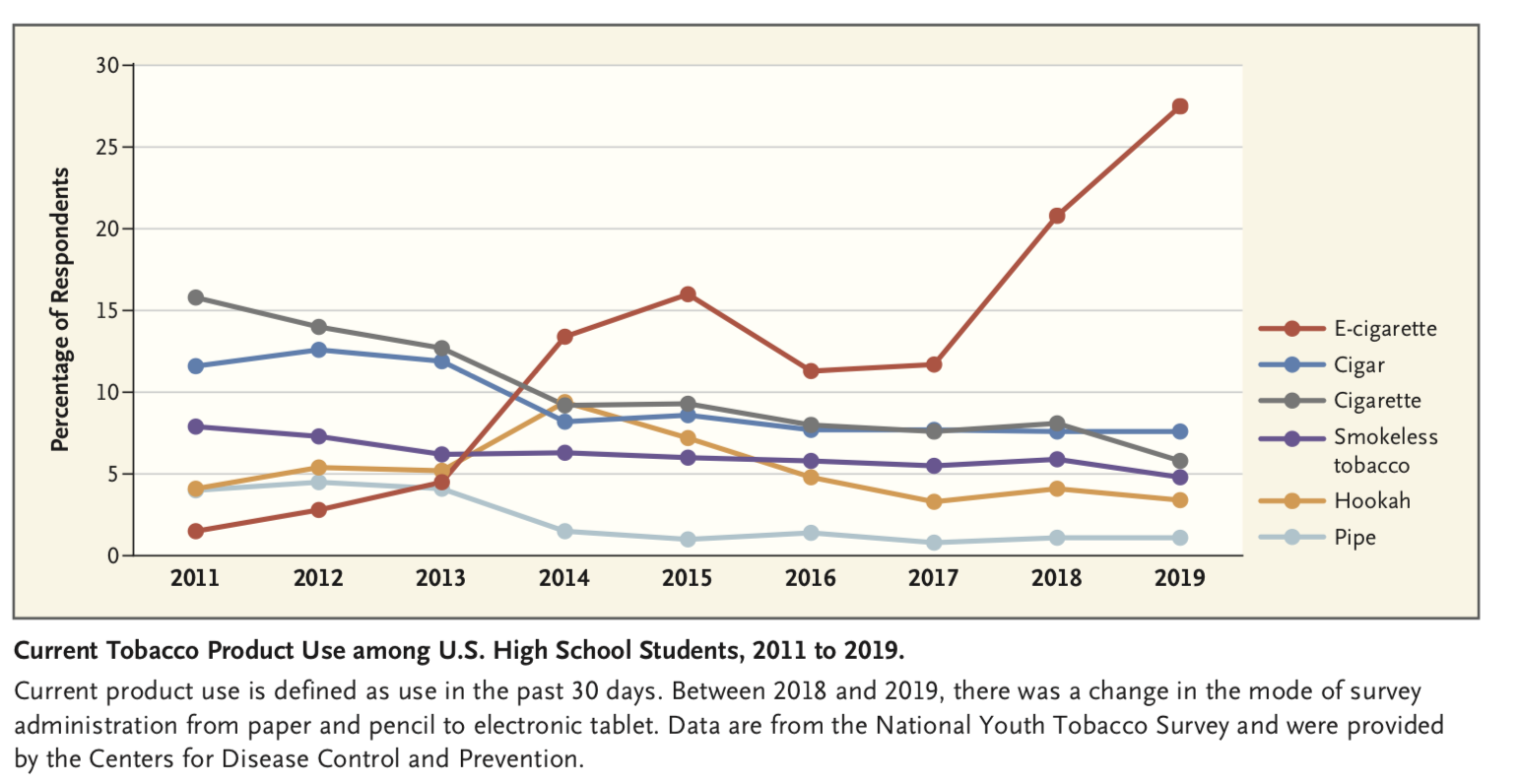

*Above figure is past 30-day use, below is ever use.*

|  |  |  |  |  |  |  |  |  |  |
| --- | --- | --- | --- | --- | --- | --- | --- | --- | --- |
|  | 2011 | *2012* | *2013* | *2014* | 2015 | 2016 | 2017 | 2018 | 2019 |
| **Percentage of middle school students who have ever used e-cigarettes \*** | 1.4% | 2.7% | 3.0% | 10.1% | 13.5% |  |  |  |  |
| **Percentage of high school students who have ever used e-cigarettes \*** | 4.7% | 10.0% | 11.9% | 27.3% | 37.7% |  | 42.2%  ** |  | 50.1% ** |
| **Entire youth sample: ever used e-cigarettes**  **(From my tabs)** |  |  | 7.75% | 19.4% | 26.63% | 22.64% | 21.12% | 24.99% | 34.95% |

*Source: Surgeon General 2016 Report (CDC)

** Different data source: Tobacco Product Use Among HS Students – **Youth Risk Behavior Survey** (I could only find 2017 and 2019)

**PATH**

|  |  |  |  |  |  |
| --- | --- | --- | --- | --- | --- |
|  |  | Wave 1 (2014) | Wave 2 (2015) | Wave 3 (2016) | Wave 4 (2017) |
| **% Ever used**  **(Chained Index)** |  | 10.67% | 16.10% | 26.41% | 31.53% |
| **By Grade (Chained)** | 12th | 19.35% | 28.02% | 48.62% | 61.18% |
|  | 10th | 13.94% | 16.19% | 22.88% | 23.46% |
|  | 8th | 5.04% | 6.17% | 8.97% | 7.11% |

|  |  |  |  |  |  |  |  |  |  |  |
| --- | --- | --- | --- | --- | --- | --- | --- | --- | --- | --- |
| *Ever Used* | *12th* |  |  |  | **19.35%**  (PATH Wave 1)  **31%** (NYTS) | **20.73%**  (PATH Wave 2)  **44.69%** (NYTS) | **30.33%**  (PATH Wave 3)  **37.19%** (NYTS) | **25%** (MTF)  **27.64%**  (PATH) Wave 4)  **35.39%** (NYTS) | **34%** (MTF)  **42.17%** (NYTS) | **40.50%**  (MTF)  **54.82%**  (NYTS) |
|  | *10th* |  |  | **10.36%** (NYTS) | **13.94%**  (PATH Wave 1)  **25.96%** (NYTS) | **15.44%**  (PATH Wave 2)  **37.54%** (NYTS) | **12.61%**  (PATH Wave 3)  **30.41%** (NYTS) | **21.40%** (MTF)  **20.52%**  (PATH) **Wave 4)**  **28.84%** (NYTS) | **28.60%**  (MTF)  **34.78%**  (NYTS) | **36.40%**  (MTF)  **45.54%** (NYTS) |
|  | *8th* |  |  | **4.73%** (NYTS) | **5.04%** (PATH Wave 1)  **14.07%** (NYTS) | **5.97%**  (PATH Wave 2)  **20.24%** (NYTS) | **8.08%**  (PATH Wave 3)  **18.56%** (NYTS) | **10.60%** (MTF)  **6.00%**  (PATH) **Wave 4)**  **16.8%** (NYTS) | **13.50%**  (MTF)  **18.20%** (NYTS) | **20.70%**  (MTF)  **29.37%**  (NYTS) |
|  | *Middle School* | **1.4%**  (NYTS) | **2.7%**  (NYTS) | **3.0%**  (NYTS) | **10.1%**  (NYTS) | **13.5%** (NYTS) |  |  |  |  |
|  | *High School* | **4.7%**  (NYTS) | **10.0%**  (NYTS) | **11.9%**  (NYTS) | **27.3%**  (NYTS) | **37.7%** (NYTS) |  |  |  |  |
|  |  | *2011* | *2012* | *2013* | *2014* | *2015* | *2016* | *2017* | *2018* | *2019* |
| *Current Users (Past 30 day use)* | *12th* |  |  | **(NYTS)** | **(NYTS)** | **(NYTS)** | **(NYTS)** | **(NYTS)** | **24.7% (NYTS)** | 34.41% (NYTS) |
|  | *10th* |  |  | **(NYTS)** | **(NYTS)** | **(NYTS)** | **(NYTS)** | **(NYTS)** | 19.11% (NYTS) | **25.7% (NYTS)** |
|  | *8th* |  |  | **(NYTS)** | **(NYTS)** | **(NYTS)** | **(NYTS)** | **5.32% (NYTS)** | **7.5% (NYTS)** | 16.09% (NYTS) |
|  | *Middle School* |  |  |  |  |  |  |  |  | **10.5% (NYTS)** |
|  | *High School* |  |  |  |  |  |  |  |  | **27.5% (NYTS)** |

**Figures using Nielsen Company e-cigarettes sales data**

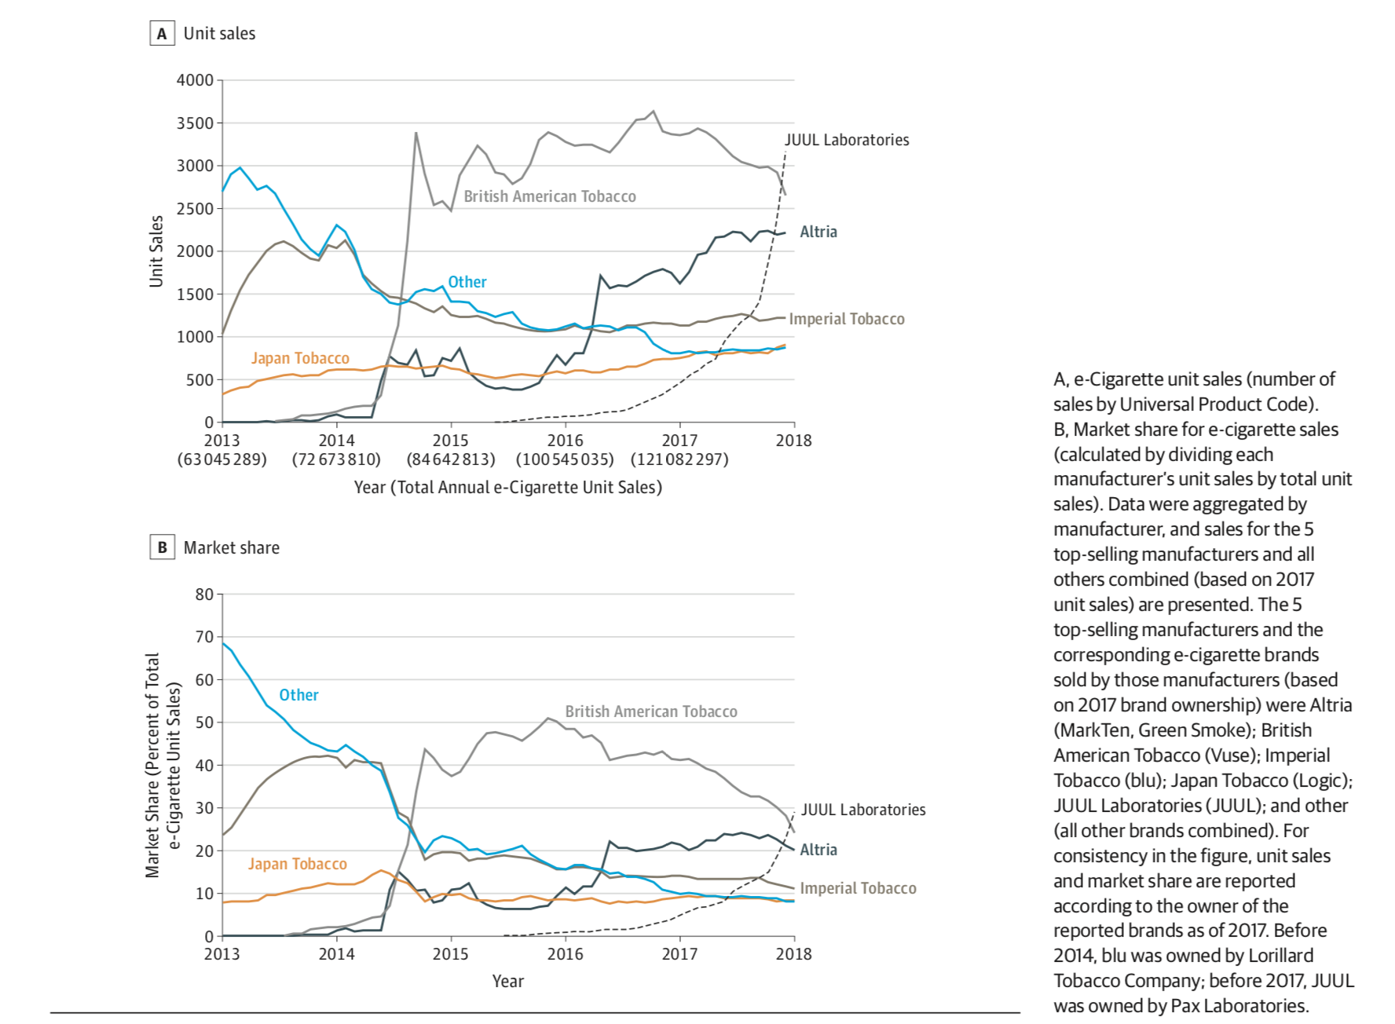

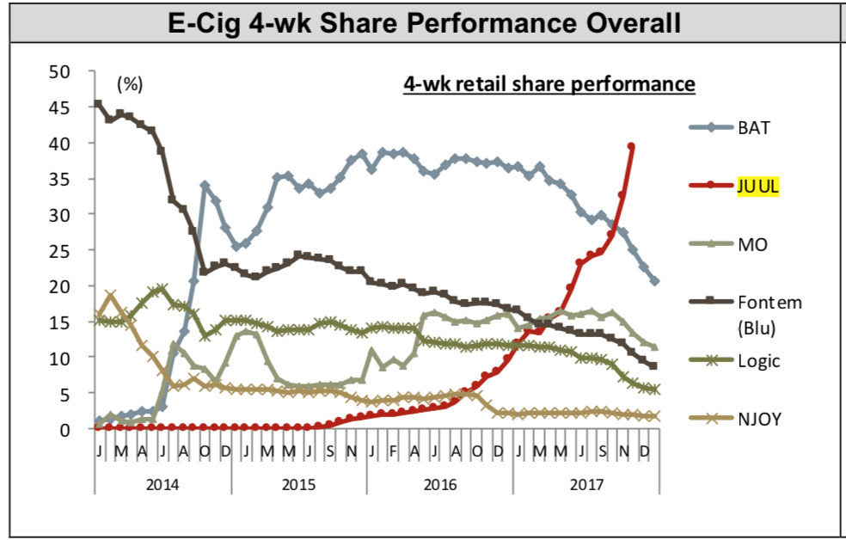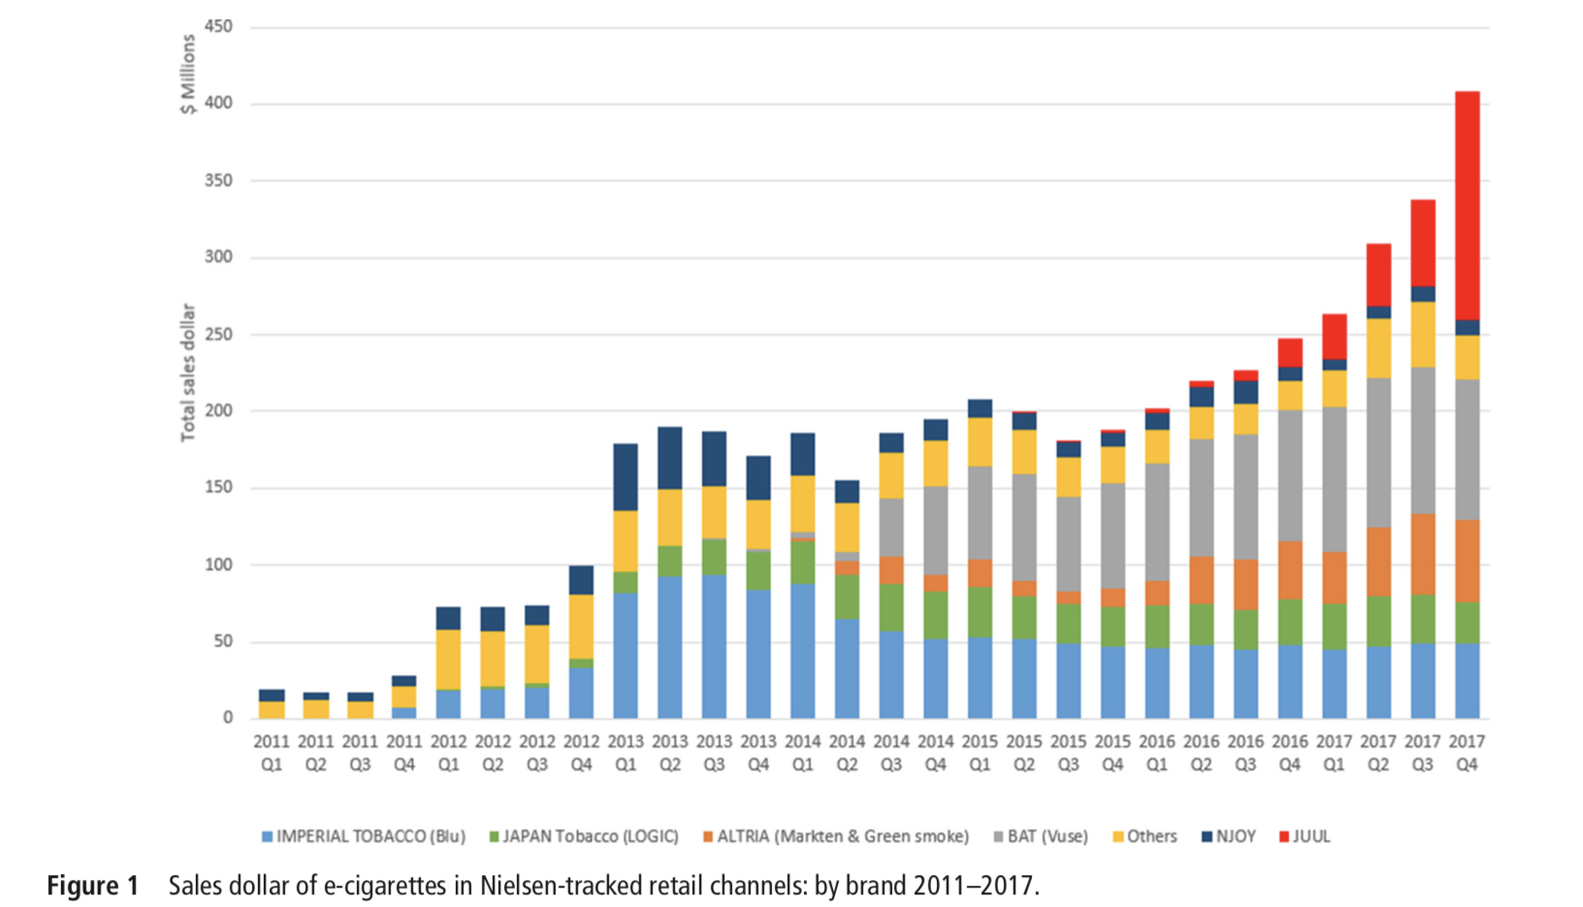

Figure 2, Nielsen Company E-cigarette retail sales data